**Summit Station Weekly Science Report**

**Reporting Period:**  January 14– January 20, 2019

**Completed by:** Gus Allen, Troy Nave

**Comments:**

Wind speeds at Summit ranged from 2.8 m/s, recorded on 2019-1-20, to 15.0 m/s on 2019-1-19. The average wind speed for the week was 7.56 m/s. Temperatures ranged from a low of -60.46˚C on 2019-1-14 to a high of -30.81˚C on 2019-1-19. The average temperature was -44.31˚C.

Summit experienced no low winds and no North winds last week.

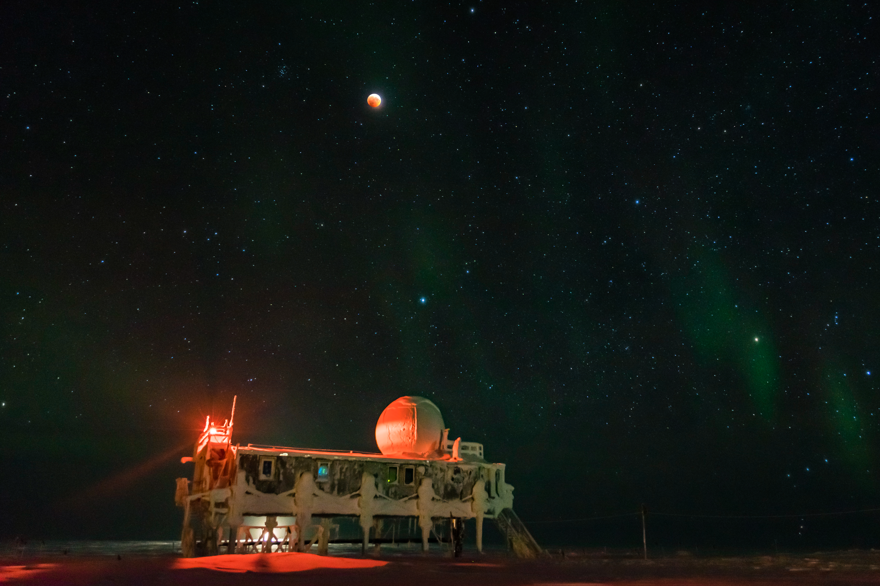

Summit had an excellent view of the January 21 Lunar eclipse, the only drawbacks

being the local viewing time (2:15am) and the ambient temp (-62f)

**Please visit the clean air log at ftp://isr.sri.com/pub/summit/ftp/science/clean_air_traffic/**

|  |  |
| --- | --- |
| **Facilities** | **Comment** |
| TAWO | H2 generator needs part; H2 being supplied by cylinder.. |
| MSF | MMCR level 0.11 pitch 0.00 roll |
| Green House |  |
| **Experiment** | **Notes** |
| NOAA CCGG flasks | Comment:  Date performed: 2019-1-17 |
| NOAA HATS flasks | Comment: twice per month  Date performed: 2019-1-8 |
| NOAA Surface Ozone | Comment: Calibrated on 2019-1-15.  % of time operating: 100% |
| NOAA Aethelometer | Comment: Instrument offsite for service.  % of time operating: 0% |
| NOAA Meteorology | Comment:  % of time operating: 100% |
| NOAA CLAP & Neph | Comment:  % of time operating: 100% |
| Radionuclide Filter | Comment: Changed every other day  % of time operating: 100% |
| Aerosol DRUM Sampler | Comment:  % of time operating: 100% |
| Bamboo Forest | Comment:  Date performed: 2019-1-19/20 |
| SnowFox | Comment:  Date performed: 2019-1-17 |
| ICESat Accumulation | Comment:  Date performed: 2019-1-16 |
| GFZ Potsdam Seismometer | Comment:  % of time operating: 100% |
| DTU Magnetometer | Comment:  % of time operating: 100% |
| UNAVCO | Comment: |
| Helmig CUGC | Comment:  % of time operating: 100% |
| Steffen Tower Instruments | Comment:  % of time operating: 100% |
| Steffen Solar Instruments | Comment:  % of time operating: 100% |
| ICECAPS-ACE Total Sky Imager | Comment: Offline for the winter.  % of time operating: 0% |
| ICECAPS-ACE Radiosonde | Comment:  Dates performed: Twice daily. |
| ICECAPS-ACE MWR | Comment:  % of time operating: 100% |
| ICECAPS-ACE SODAR | Comment:  % of time operating: 100% |
| ICECAPS-ACE POSS | Comment:  % of time operating: 100% |
| ICECAPS-ACE MASC | Comment: Instrument offsite for service; expected return 2019-06.  % of time operating: 0% |
| ICECAPS-ACE MMCR | Comment: Brief outage for system restart – 1-15  % of time operating: 99% |
| ICECAPS-ACE CAPABL | Comment: On 1-18 the laser was briefly powered down to remove snow over the window. Instrument is presently operating normally using laser 2.  % of time operating: 99% |
| ICECAPS-ACE MPL | Comment:  % of time operating: 100% |
| ICECAPS-ACE Ceilometer | Comment:  % of time operating: 100% |
| ICECAPS-ACE PAERI | Comment:  % of time operating: 100% |
| ICECAPS-ACE IcePIC | Comment: Images captured 1-16  Date(s) performed: |
| ICECAPS-ACE CLASP | Comment: Instrument offsite for service; expected return 2019-02.  % of time operating: 0% |
| ICECAPS-ACE CPC | Comment: Instrument offsite for service; expected return 2019-02.  % of time operating: 0% |
| ICECAPS-ACE OPC | Comment: OPC was de-rimed 1-15 to 1-17. Instrument is operational and collecting data, but files are not presently being transferred via DATAMAN. Maintenance and config of back-end ACE systems is ongoing.  % of time operating: ~50% |
|  |  |  |
|  |  |  |